**Daily Scrum or Standup Meeting**

Team name: ______Team 6__________

Scrum Master: ______Joshua McClung_

Date:______________11/4/22________

|  |  |  |  |
| --- | --- | --- | --- |
| **Team Member** | **What did you do since the last scrum?** | **What do you plan to do before the next scrum?** | **What obstacles do you have?** |
| Wesley Edwards | Inventory add stock, create order page for cashier | Employee hour page | Need employee model to be finished |
| Geoffrey Haselden | Employee works, worked on tests | Employee model completely done, bug ticket | None |
| Joshua McClung | Got balanced completely finished, order flow plus stock and balance code complete, working on tests | Finish stock and balance flow, start on drink image path | None |
| Landon Doyle | Merge PRS | Push everything up that is WIP, get display order cashier page done, get started on payroll | Sick |

# Burndown

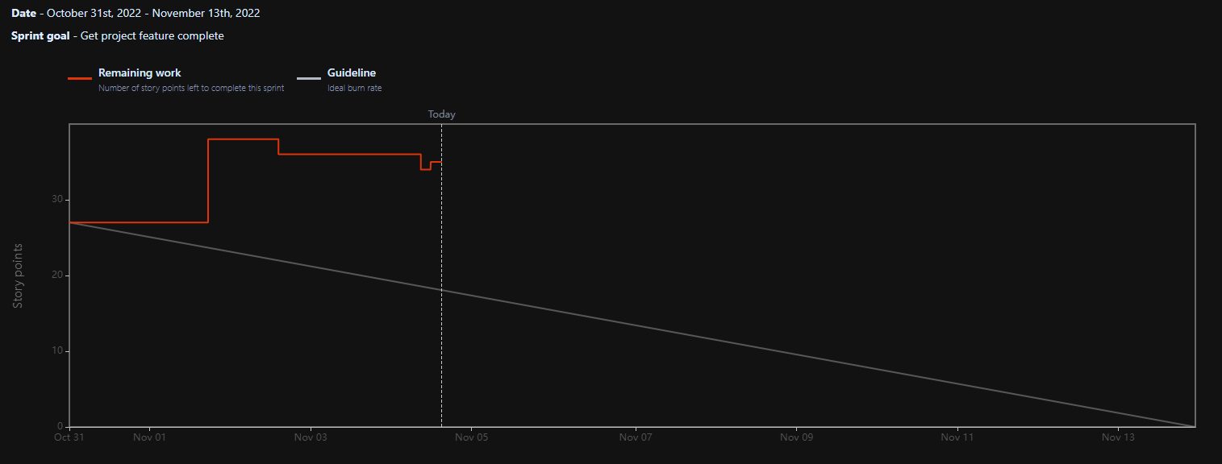

# Screenshot of you project board

